*2019 AnoPCN: Video Anomaly Detection via Deep Predictive Coding Network*

AnoPCN has a deep recurrent architecture containing Predictive Coding Module (PCM) and Error Refinement Module (ERM). PCM is designed as a convolutional recurrent neural network with feedback connections carrying frame predictions and feedforward connections carrying prediction errors.

PCM is used in *k* consecutive previous frames $\{I_{t-k}, I_{t-k+1}, …, I_{t-1}\}$, ERM is used in $I_{t}$.

In the predictive stage, only PCM is used, in the refinement stage, only ERM is used.

PCM generates a predicted frame, ERM takes as input the current prediction error from PCM and feed it into U-Net to reconstruct the prediction error. First, PCM generates a prediction frame ${\hat{I}}_{t}$ from previous frames. Next, ERM reconstructs the prediction error $E_{t}$ and adds a refinement ${\hat{E}}_{t}$ to ${\hat{I}}_{t}$ to obtain a reconstructed frame ${\hat{I}}_{t}^{r}$.

PCM consists of ConvLSTM, Conv Unit and Prediction Error Processing (PEP: U-Net) Unit.

In previous k frames, ConvLSTM generates a prediction frame $\{{\hat{I}}_{t-k}, {\hat{I}}_{t-k+1}, …, {\hat{I}}_{t-1}\},$ which will be used to obtain the prediction error $\{E_{t-k+1}, E_{t-k+2}, …, E_{t-1}\}$. PEP is to encode the prediction error $\{R_{t-k+1}, R_{t-k+2}, …, R_{t-1}\}$ and feeds it into ConvLSTM to update its internal states $\{{\hat{I}}_{t-k+1}, {\hat{I}}_{t-k+2}, …, {\hat{I}}_{t}\}$.

The architecture of ERM is quite similar to the PEP structure. ERM doesn’t have the last layer.

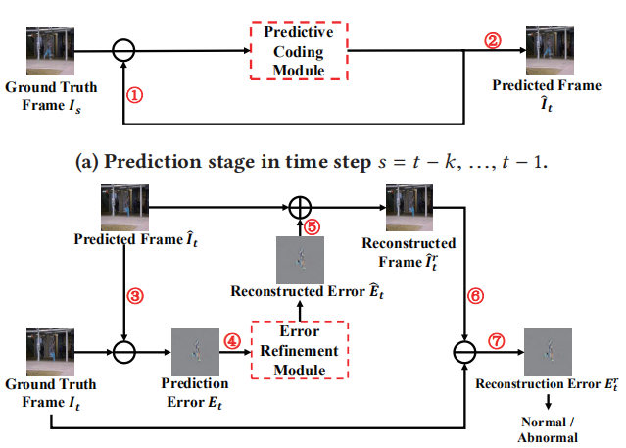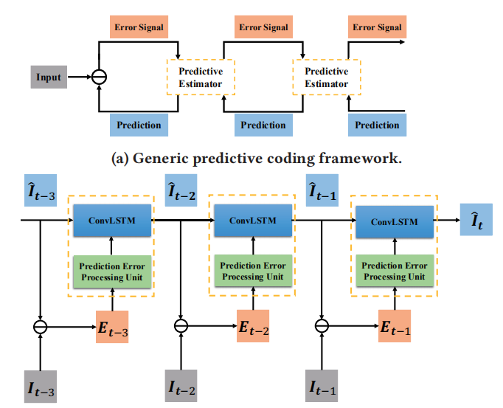

Narrow regularity score gaps between normal frames and abnormal ones:

$$∆S=\frac{\sum_{t∈N}{S_{t}}}{T_{n}}-\frac{\sum_{t∈A}{S_{t}}}{T_{a}}$$

Where $S_{t}$ is the regularity score of frame *t*. *N* and *A* are the sequence number sets of normal frames and abnormal ones. $T_{n}$ and $T_{a}$ are the total numbers of normal frames and abnormal ones.

To solve the problem of narrow $∆S$, they propose a new strategy for reconstruction models by decomposing reconstruction into prediction and refinement.

They take the normalize Peak Signal-to-Noise Ratio (PSNR) of ${\hat{I}}_{t}^{r}$ as the regularity score $S_{t}$ of video frame $I_{t}$. PSNR of video frame in time step *t*:

$${PSNR}_{t}=10\log_{10}{\frac{{\left[\max_{(i,j)}{{\left({\hat{I}}_{t}^{r}\right)}_{(i,j)}}\right]}^{2}}{\frac{1}{P}{\left\|I_{t}-{\hat{I}}_{t}^{r}\right\|}_{2}^{2}}}$$

Where $\max_{(i,j)}{{\left({\hat{I}}_{t}^{r}\right)}_{(i,j)}}$ is the maximum value of image intensity elements, and *P* is the total number of pixels in $I_{t}$.

The lower ${PSNR}_{t}$ is more likely $I_{t}$ contains anomaly. Normalized ${PSNR}_{t}$ is exploited to quantify the regularity of frame $I_{t}$:

$$S_{t}=\frac{{PSNR}_{t}-\min_{t}{{PSNR}_{t}}}{\max_{t}{{PSNR}_{t}}-\min_{t}{{PSNR}_{t}}}$$

Frame $I_{t}$ is abnormal or not can be judged by if $S_{t}$ is smaller than a given threshold. $∆S$ can be used to quantify the ability of discriminating anomaly and regularity for VAD techniques.